**Assignment No. 01**

**Title:** [**Web Design and Programming Lab-I**](https://classroom.google.com/u/2/c/Njc5NTg4OTk0MTU0)

*Course title: Structured Programming Language*

*Course code: CSE-312*

*3rd Year 1st Semester Examination 2023*

**Date of Submission**: 26-Aug-2024



**Submitted to-**

###### **Md. Rafsan Jani**

*Assistant Professor*

*Department of Computer Science and Engineering*

*Jahangirnagar University*

*Savar, Dhaka-1342*

|  |  |  |  |
| --- | --- | --- | --- |
| **Sl** | Class Roll | Exam Roll | Name |
| 01 | 383 | 210903 | Abdullah Nazmus-Sakib |

|  |
| --- |
| **Problem Number:01** |

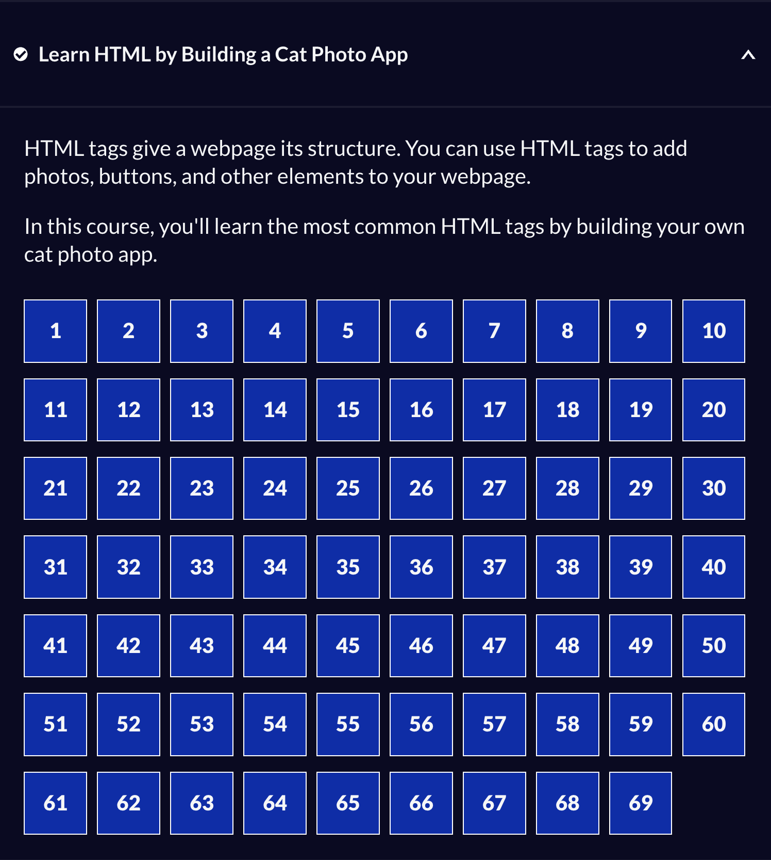

|  |
| --- |
| **Problem Number:** |

Source Code:

<!DOCTYPE html>

<html lang="en">

<head>

<title>CatPhotoApp</title>

</head>

<body>

<main>

<h1>CatPhotoApp</h1>

<section>

<h2>Cat Photos</h2>

<!-- TODO: Add link to cat photos -->

<p>See more <a target="_blank" href="https://freecatphotoapp.com">cat photos</a> in our gallery.</p>

<a href="https://freecatphotoapp.com"><img src="https://cdn.freecodecamp.org/curriculum/cat-photo-app/relaxing-cat.jpg" alt="A cute orange cat lying on its back."></a>

</section>

<section>

<h2>Cat Lists</h2>

<h3>Things cats love:</h3>

<ul>

<li>cat nip</li>

<li>laser pointers</li>

<li>lasagna</li>

</ul>

<figure>

<img src="https://cdn.freecodecamp.org/curriculum/cat-photo-app/lasagna.jpg" alt="A slice of lasagna on a plate.">

<figcaption>Cats <em>love</em> lasagna.</figcaption>

</figure>

<h3>Top 3 things cats hate:</h3>

<ol>

<li>flea treatment</li>

<li>thunder</li>

<li>other cats</li>

</ol>

<figure>

<img src="https://cdn.freecodecamp.org/curriculum/cat-photo-app/cats.jpg" alt="Five cats looking around a field.">

<figcaption>Cats <strong>hate</strong> other cats.</figcaption>

</figure>

</section>

<section>

<h2>Cat Form</h2>

<form action="https://freecatphotoapp.com/submit-cat-photo">

<fieldset>

<legend>Is your cat an indoor or outdoor cat?</legend>

<label><input id="indoor" type="radio" name="indoor-outdoor" value="indoor" checked> Indoor</label>

<label><input id="outdoor" type="radio" name="indoor-outdoor" value="outdoor"> Outdoor</label>

</fieldset>

<fieldset>

<legend>What's your cat's personality?</legend>

<input id="loving" type="checkbox" name="personality" value="loving" checked> <label for="loving">Loving</label>

<input id="lazy" type="checkbox" name="personality" value="lazy"> <label for="lazy">Lazy</label>

<input id="energetic" type="checkbox" name="personality" value="energetic"> <label for="energetic">Energetic</label>

</fieldset>

<input type="text" name="catphotourl" placeholder="cat photo URL" required>

<button type="submit">Submit</button>

</form>

</section>

</main>

<footer>

<p>

No Copyright - <a href="https://www.freecodecamp.org">freeCodeCamp.org</a>

</p>

</footer>

</body>

</html>